Unlink social flow

Flow diagram
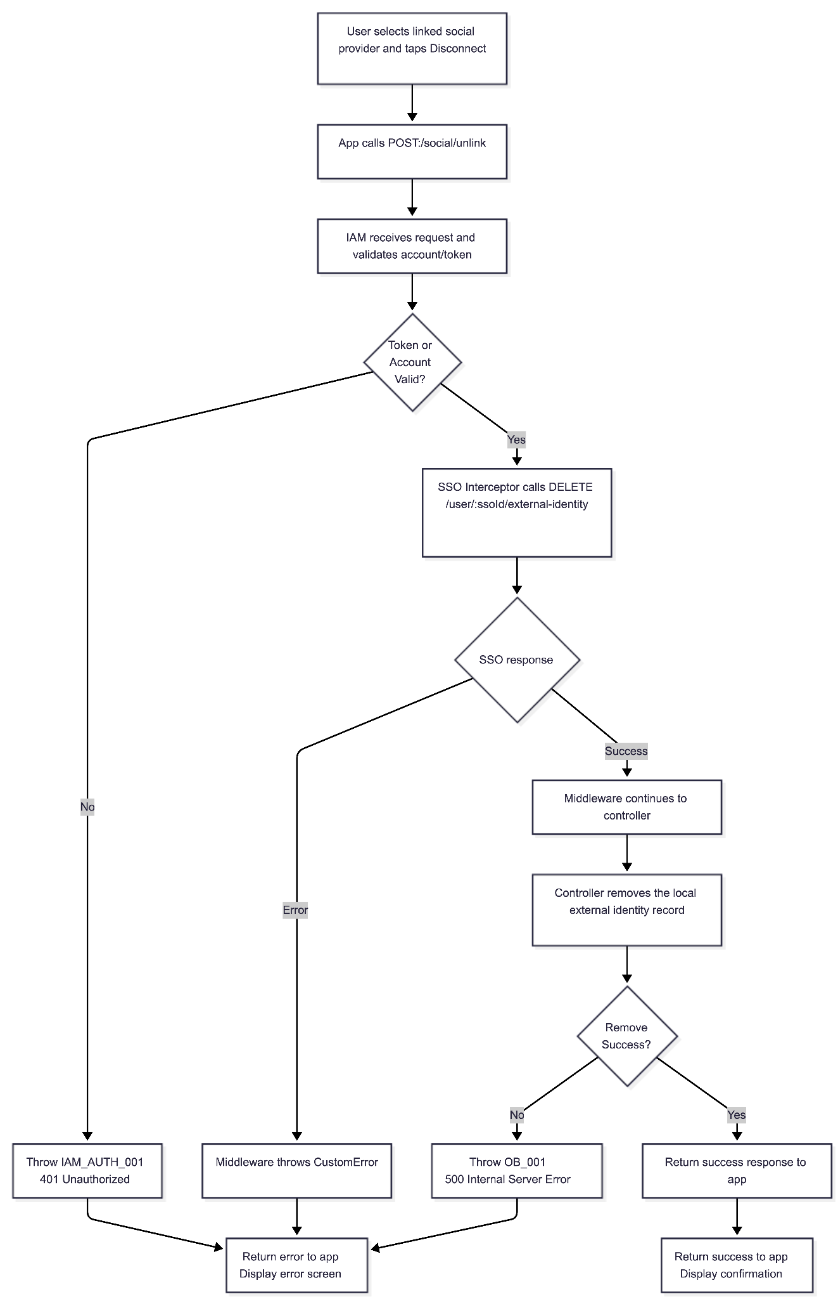

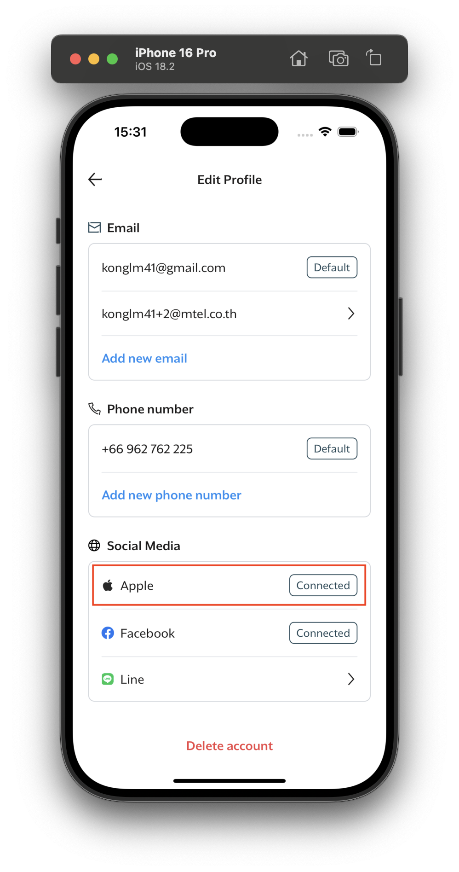
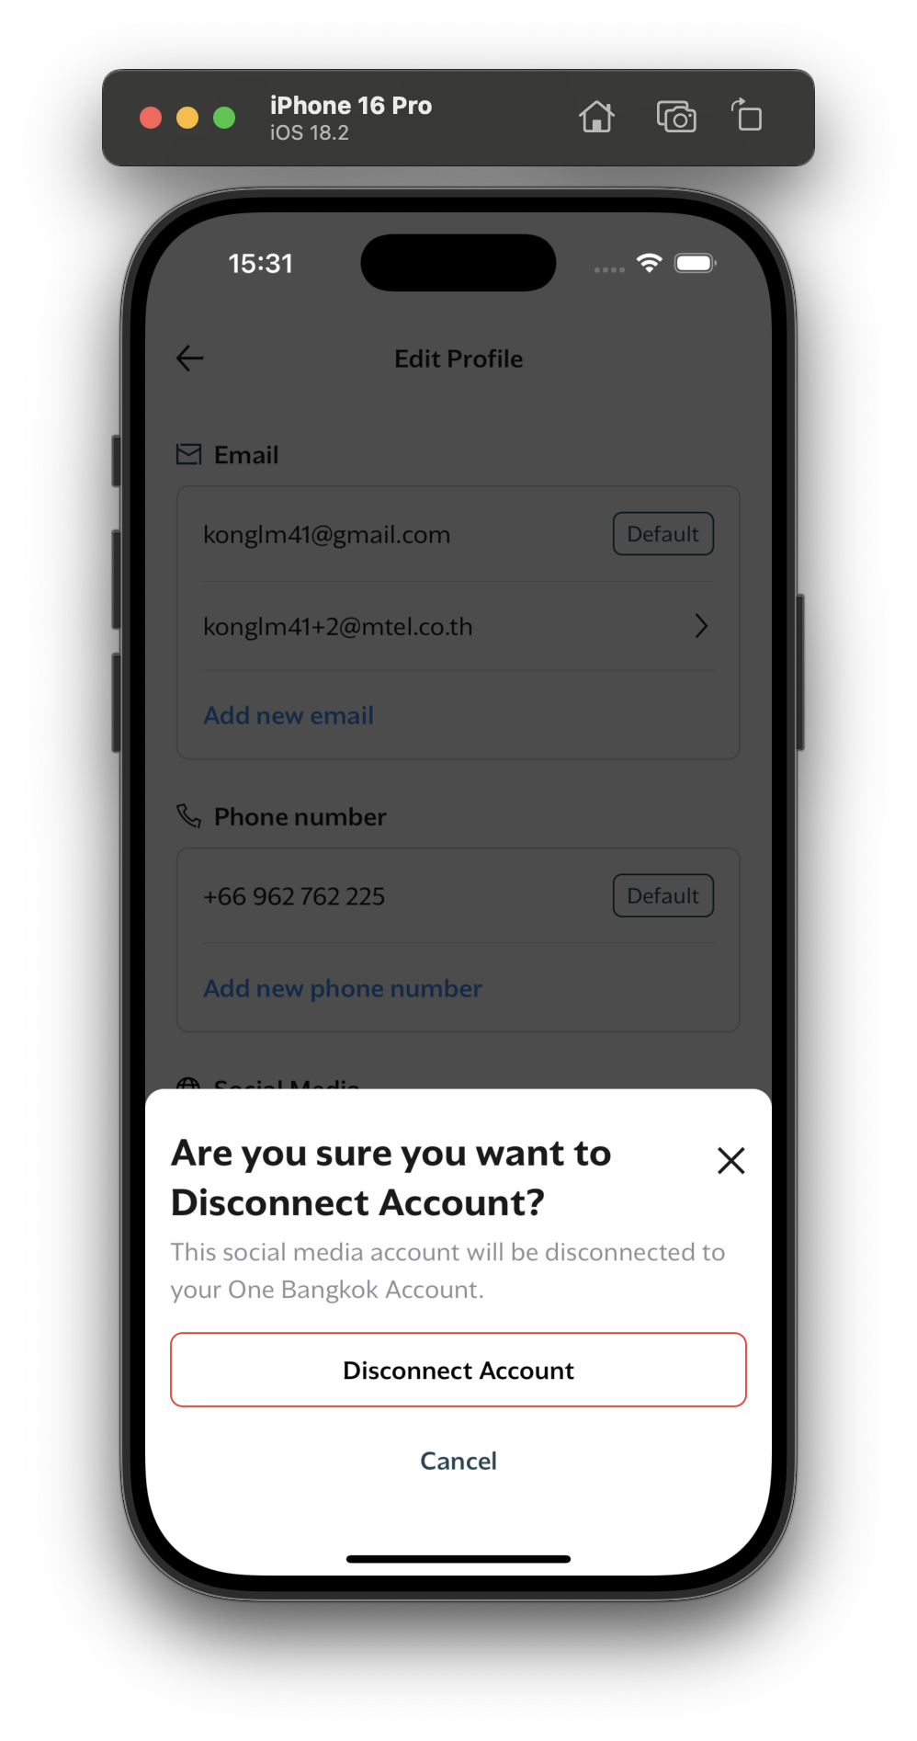
Preview Screen

Sequence diagram
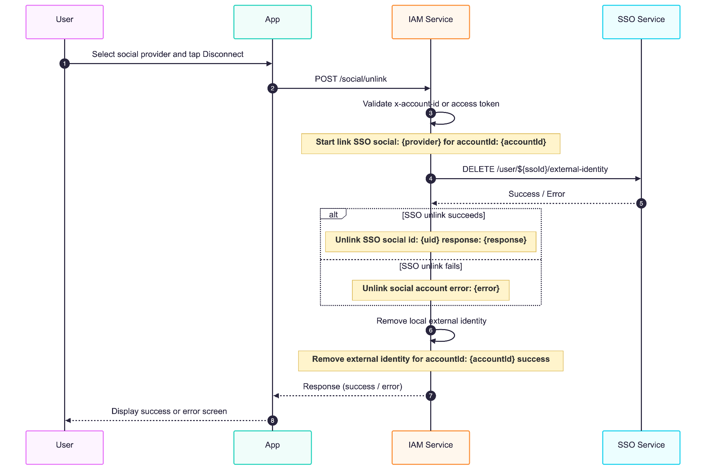

Api description - IAM

Description
Unlink a social external identity from the current account.

Example Request
POST /social/unlink HTTP/1.1
Content-Type: application/json
x-account-id: acc_1234567890
app-version: 1.0.0
{
"provider": "facebook",
"uid": "1234567890"
}

Headers
Name | Required | Description
x-account-id | Optional | Current account ID when available
x-access-token | Optional | Bearer auth token when account ID is not provided
app-version | Recommended | Used by SSO interceptor to decide whether SSO is required

Request Body
{
"provider": "facebook",
"uid": "1234567890"
}

Name | Type | Required | Description
provider | string | Yes | Social provider type, e.g. facebook, apple, line
uid | string | Yes | External social user identifier

Example Success Response
{
"data": true
}

Response data:
true indicates the unlink operation completed successfully.

Error Scenarios
Error Code | HTTP Status | Description | Cause | Resolution
IAM_AUTH_001 | 401 | Invalid or missing authentication token | Token validation failed or no token provided | Provide valid access token or account ID
IAM_AUTH_006 | 401 | Account not found | Account ID references non-existent account | Ensure user is logged in with valid account
IAM_IDT_007 | 400 | Failed to unlink external identity | SSO unlink failed or unlink operation invalid | Confirm social identity exists and try again
IAM_SSO_007 | 400 | Missing SSO external identity for the account | IAM account has no linked SSO identity | Ensure account has been created via SSO
OB_001 | 500 | Unexpected internal server error | Database error or unexpected exception | Retry later or contact support

Error Response Examples

400 Bad Request - Unlink Failed
{
"error": {
"code": "IAM_IDT_007",
"message": "failed to unlink external identity",
"stack": "Error: failed to unlink external identity\n at SocialController.unlinkSocial"
}
}

400 Bad Request - Missing SSO Identity
{
"error": {
"code": "IAM_SSO_007",
"message": "missing SSO external identity",
"stack": "..."
}
}

401 Unauthorized - Invalid Token
{
"error": {
"code": "IAM_AUTH_001",
"message": "invalid credentials",
"stack": "..."
}
}

401 Unauthorized - Account Not Found
{
"error": {
"code": "IAM_AUTH_006",
"message": "account not found",
"stack": "..."
}
}

500 Internal Server Error
{
"error": {
"code": "OB_001",
"message": "internal server error",
"stack": "..."
}
}

Api description - SSO

Example Request
POST /user/sso_abc123def456/external-identity/delete HTTP/1.1
Content-Type: application/json
clientId: iam_service_client
clientSecret: secret_key_12345
{
"value": "facebook_user_id_12345",
"provider": "facebook"
}

Headers
Name | Type | Required | Description
clientId | string | Yes | Client identification key
clientSecret | string | Yes | Client secret for authentication

Path Parameter
Name | Type | Required | Description
ssoId | string | Yes | The public SSO user ID, for example sso_xxxx

Request Body
Field | Type | Required | Description
value | string | Yes | Unique user identifier from the social provider
provider | string | Yes | External identity provider: 'facebook', 'apple', 'line'

Success Response (200 OK)
{
"result": true,
"message": "External Identity provider: facebook and uid: facebook_user_id_12345 unlinked successfully."
}

Error Handling
Status Code | Source | Error Code | Message | User-Facing Result
400 | SSO | 400 | Validation failed | Display error screen
400 | SSO | SSO_IDP_004 | Failed to unlink external identity | Display error screen
400 | SSO | SSO_IDP_008 | External identity does not exist | Display error screen
401 | SSO | 401 | Client credentials are required | Display error screen
401 | SSO | 401 | Invalid client credentials | Display error screen
404 | SSO | SSO_ACC_002 | SSO ID not found | Display error screen
500 | SSO | 500 | Internal Server Error | Display error screen

Example Error Responses

400 Bad Request - Validation Failed
{
"error": {
"statusCode": 400,
"message": "Validation failed",
"details": {
"errors": {
"formErrors": [],
"fieldErrors": {
"provider": ["Invalid enum value. Expected 'facebook' | 'google' | 'apple' | 'line'"]
}
}
},
"stack": "ZodValidationException: Validation failed\n at ..."
}
}

400 Bad Request - Failed to Unlink External Identity
{
"error": {
"statusCode": "SSO_IDP_004",
"message": "Failed to unlink external identity",
"stack": "CustomError\n at ..."
}
}

400 Bad Request - External Identity Does Not Exist
{
"error": {
"statusCode": "SSO_IDP_008",
"message": "External identity does not exist",
"stack": "CustomError\n at ..."
}
}

401 Unauthorized - Client Credentials Are Required
{
"error": {
"statusCode": 401,
"message": "Client credentials are required",
"stack": "UnauthorizedException: Client credentials are required\n at ..."
}
}

401 Unauthorized - Invalid Client Credentials
{
"error": {
"statusCode": 401,
"message": "Invalid client credentials",
"stack": "UnauthorizedException: Invalid client credentials\n at ..."
}
}

404 Not Found - SSO ID Not Found
{
"error": {
"statusCode": "SSO_ACC_002",
"message": "SSO ID not found",
"stack": "CustomError\n at ..."
}
}

500 Internal Server Error - Unexpected Failure
{
"error": {
"statusCode": 500,
"message": "Internal Server Error",
"stack": "Error: Internal Server Error\n at ..."
}
}

4. Cache keys

Key | TTL | Source | Purpose
EXTERNAL_IDENTITY_CACHE_KEY_KEY_{accountId} | 3600 seconds | ExternalIdentityService | Stores external identity cache keys for the account so they can be invalidated together.
EXTERNAL_IDENTITY_CACHE_KEY_account_id_{accountId} | 3600 seconds | ExternalIdentityService.GetExternalIdentity | Cached external identities by account ID. Deleted after successful local social unlink.
EXTERNAL_IDENTITY_CACHE_KEY_identifier_{identifier} | 3600 seconds | ExternalIdentityService.GetExternalIdentity | Cached external identities by identifier. Deleted through the account key registry.
EXTERNAL_IDENTITY_CACHE_KEY_uid_{uid} | 3600 seconds | ExternalIdentityService.GetExternalIdentity | Cached external identities by external UID. Deleted through the account key registry.

